NSQ1 S25 Course Assignment 1

For this assignment, you should model an online bookstore based on the Book section of [Amazon (UK)](https://www.amazon.co.uk/gp/browse.html?node=266239&ref_=nav_em__bo_books_0_2_9_2). The model needs to be a relational model. You can add as much as you like, but you need at least the following:

## Books

See for yourself what you can find about a book in the store, but keep in mind that a bookstore has more copies of a book, and sometimes they are sold out.

## Category

The Amazon bookstore operates with categories to help browsing for books. You can see the categories in the following screen dump:

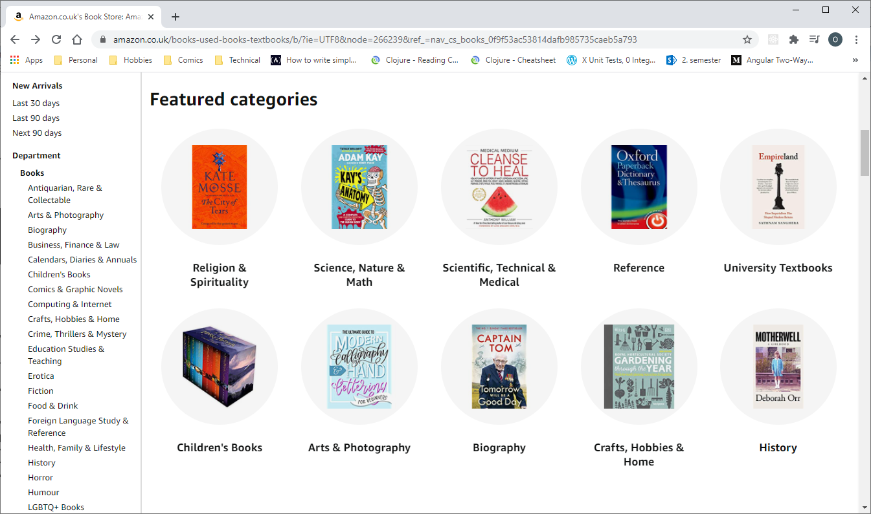

Categories

Note that the categories have subcategories, and that a book can belong to more than one category.

## Character and Genre

When you drill down into various categories (e.g. Fiction->Science Fiction or Fiction->Fantasy), you will find that some of them come with character types and genres. A book can have more character types and belong to more genres.

## Customer

If you cannot find out how Amazon registers customers, come up with your own ideas.

## Order

Orders need at least a unique identifier and a date. You should be able to order any number of books, including several copies of the same book.

# Question 1

Make a conceptual model of the bookstore. Get as close to the actual bookstore as possible.

# Question 2

Map the model to the database. (Logical model)

# Question 3

Implement the model using SQL. Add some data to get a feel for how it works. It is recommended to follow the guidelines below.

* All tables should have data
* Most, if not all, data should be related to something
* The data should contain a hierarchy of categories
* Of course, add as much data as you need to test your answers to Question 4, below.

IN THE NOTE FILE

# Question 4

Answer the following questions in SQL using your model from previous questions.

IN THE NOTE FILE

## Modifying data

Use SQL to execute the following scenarios. If nothing else is stated, assume you know the ids of the entities involved.

1. Sell a book to a customer.
2. Change the address of a customer.
3. Add an existing author to a book.
4. Retire the "Space Opera" category and assign all books from that category to the parent category. Do not assume you know an id of the parent category.
5. Sell 3 copies of one book and 2 of another in a single order

## Querying data

Write SQL statements to return the following data

1. All books by an author
2. Total price of an order
3. Total sales to a customer
4. Books that are categorized as neither science fiction nor fantasy (**Note:** This is harder than you think. A book can have more categories. Make sure you don’t return books that are fantasy romance, for instance.)
5. Average page count by genre
6. Categories that have no sub-categories
7. ISBN numbers of books with more than one author
8. ISBN numbers of books that sold at least X copies (you decide the value for X)
9. Number of copies of each book sold – unsold books should show as 0 sold copies.
10. Best-selling books: The top 10 selling books ordered in descending order by number of sales.
11. Best-selling genres: The top 3 selling genres ordered in descending order by number of sales.

**Note:** In the next three exercises, subcategories of science fiction also count as science fiction, and so do subcategories of subcategories, and so on. It’s not enough to just look for the science fiction category. (Hint: Google "WITH RECURSIVE")

1. **(Optional)** All science fiction books
2. **(Optional)** Characters used in science fiction books
3. **(Optional)** Number of books in each category

# Question 5

Write a report on the experience gained by completing Question 1 through 4 above. The report should contain answers to the questions

* What were the decisions taken in the modelling?

1. A foreign key is present in Category, pointing to the parent Category ID in a recursive manner.

* Why were these decisions taken?

1. To establish a hierarchical structure of categories and sub-categories. A category can be made into a subcategory by having a parent assigned.

* What were the consequences of these decisions?

1. The Category table is larger, but it doesn't need to reference anything other than itself to maintain a hierarchical category system.

* What were the difficult and easy parts of the exercise?

Difficult - coming up with the initial Entity-Relationship Diagram based on the structure of the Amazon bookstore, since all the different relationships between domain entities had to be accounted for in the design process. Easy - transcribing the EER diagram to GRD, thanks to clear and useful instructions on the Troels website; writing the less complex queries

# Rules

* Make the exercise in groups of 2 – 4
* Hand in to itslearning no later than 16 February if you want feedback